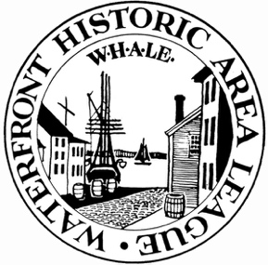
WHALE Board Member Interest Form
(DEADLINE MAY 15, 2024)

Please fill out the form below with information about yourself and why you are interested in joining WHALE’s Board of Directors

Name:

(First) (Middle Initial) (Last)
Town/State of Residence: Town/State of Employment (optional):

Best Phone to Contact:

Email Address:

How did you hear about this opportunity?
□ Referred by someone □ WHALE e- news/Web site □ Other Network Affiliations (Clubs, Other Boards, Committees, Memberships, Employer):

Why are you interested in joining WHALE’s board?

What skills/experience does the nominee bring? Resumes may be emailed to the contact below (Optional).
□ Fundraising □ Legal □ Strategic planning □ Marketing
□ Financial management □ Human resources □ Governance □ Museum
□ Community outreach □ Public History □ Preservation □ Education
□ Diversity/Equity/Inclusion □ Others:

Thank you!
Please email this form to Erin Miranda at emiranda@waterfrontleague.org or mail to our office at
15 Johnny Cake Hill, New Bedford MA 02740

